Real-Time Bridge Monitoring

Project Plan

Version 1.3

Revision History

Date | Version | Description | Author
2013-10-10 | 1.0 | Initial Draft | DSD Staff
2013-10-28 | 1.1 | Project Plan v1.0 | Real-Time Bridge Monitoring team
2014-01-06 | 1.2 | Update chapters 1, 2, 3 and 4  Text format | Andrea Bottoli
2014-01-07 | 1.3 |  | Lorenzo Paglairi

Table Of Contents
1.Introduction 4
1.1Purpose of this document 4
1.2Intended Audience 4
1.3Scope 4
1.4Definitions and acronyms 4
1.5References 5
2.Background and Objectives 6
2.1Project Goal 6
2.2Project Requirements 6
2.3Project Milestone 6
2.4Project Deliverables 7
2.5Project testing 7
2.6Project delivery 7
3.Organization 8
3.1Project group 8
3.2Customer 8
3.3Supervisor 8
4.Development process 9
4.1Introduction 9
4.2Project Phases 9
4.3Roles 9
4.4Quality Assurance 10
5.Deliverables 11
6.Inputs 12
7.Project risks 13
8.Communication 14
9.Configuration management 15
10.Project plan 16
10.1Time schedule 16
10.2Activity plan 17

Introduction
Real-Time Bridge Monitoring is a project for the Distributed Software Development course held by Politecnico di Milano, Mälardalen University and University of Zagreb.

Purpose of this document
The purpose of this document is to assist in the planning of the development of the project 'Real-Time Bridge Monitoring”, as a part of the Distributed Software Development course.
This document will be the starting point and first deliverable of the project.
It is essential for the beginning phase of the development process, and will be slightly updated throughout the whole project.

Intended Audience
This document is written primarily for the development team.
The crucial planning decisions will be recorded in this document, so the development team will use it as a guidance while planning their time, splitting tasks and it will serve as a basis for the next phases of the project.
Also, this document is intended for the supervisors, in order to give them insight into our initial view and plan of the project.

Scope
This document will have main focus on the organization of the team and planning and distribution of work during the development process.
Firstly, the background and objectives of the project will be briefly explained.
After that, the organization within the team will be shown, regarding the distribution of work and responsibilities of each team member. Also, the stakeholders of the project will be introduced.
The development process that will be used in the development of the system will be presented in the fourth section. Here there will also be a brief description of each increment of the system.
Each deliverable will be described in the sixth section. This part will be updated throughout the project in order to record the delivered products and documents, and passed deadlines.
Further on, the inputs to the system will be presented. The inputs present the data that will be received from the customer and be processed by the system.
The document will also cover communication tools and conventions that we have agreed upon. In this chapter, it will be described in details how the information flow should look like.
Finally, configuration management and the project plan will be introduced. The project plan will cover the main planning decisions main about the project, regarding time, milestones, activities. This plan will be represented in an intuitive way, by using tables, charts and Gantt charts with timestamps.

Definitions and acronyms

Definitions

Keyword | Definitions
Real-Time Bridge Monitoring | The project name

Acronyms and abbreviations

Acronym or  abbreviation | Definitions
POLIMI | Politecnico di Milano
MDH | Mälardalen University
FER | University of Zagreb
DSD | Distributed Software Development

References
Project homepage: http://www.fer.unizg.hr/rasip/dsd/projects/real-time_bridge_monitoring
Project application: http://161.53.67.134/BridgeMonitoring/
Project documents: http://www.fer.unizg.hr/rasip/dsd/projects/real-time_bridge_monitoring/documents

Background and Objectives

Project Goal
The Goal of this project is to develop a system that can help the monitoring process of bridges and to improve the speed of reaction at dangerous events. The system has to indicate the level of alarm in which the bridge is, so eventual security measures can be performed by the users; also make these information available on the web.

Project Requirements

Data sources
The system gathers data from various sensors that are:
- Anemometer
- Hydrometer
- Echo sonar
- Cameras

Data calculations
The system has to calculate the various characteristics of the bridge:
- The bridge stresses
- The forces acting on the bridge
- The wind speed
- The impact of the amount of traffic and its direction

User interface
The system has a user interface on which all the information will be displayed; it will also be displayed a temporal graph showing the temporal trend of values in the current day. The interface let to the users the possibilities to change some bounds or other variables.
There will be also the possibility to display historical data of the bridge on graph to allow the users to make comparison from the current state and the historical one; the users have to insert the period of time that they will want to see.

Web Application
The system can be reached on web to allow the uses to see all the information on their own devices.

Project Milestone
The main milestones are:
- Project Vision
- Project Plan
- Requirements definitions
- Design description
- Alpha prototype
- Beta prototype
- Acceptance test
- Final product

Project Deliverables
The deliverable are:
- Project Plan & Vision (with presentation)
- Project Plan Document
- Project Requirements and Architecture (with presentation)
- Design Description
- Alpha Prototype (with presentation)
- Beta Prototype (with presentation)
- Testing Report
- Final Project (with presentation)

Project testing
The testing phase expect to test the system reaction at some unexpected situations as the loss of network connection, loss of data, incorrect data, data missing and some other cases.

Project delivery
The final project/product will be delivered at 13-01-2014 on the web page with all the source codes.

Organization

Project group
The project group consists of seven members all together.
There are three members from the Italian side, that are coming from the Politecnico di Milano University: Andrea Bottoli, Lorenzo Pagliari and Marko Brčić.
The other four members are from the Mälardalens University: Dzana Kujan, Miraldi Fifo, Jörn
Tillmanns and Nikola Radisavljevic.
Their roles in the group are defined and represented in the table below.

Name | Initials | Responsibility (roles)
Andrea Bottoli | AB | Project Manager
Dzana Kujan | DK | Team Leader
Marko Brcic | MB | Documentation manager
Lorenzo Pagliari | LP | Design manager
Miraldi Fifo | MF | Testing manager
Jorn Tillmanns | JT | Database manager
Nikola Radisavljevic | NR | Integration manager

Customer
There are two customers in this project: they are Ballio Francesco and Crotti Gianluca.

Supervisor
There are two supervisors in this project: they are Mirandola Raffaela and Di Nitto Elisabetta.
This organization structure is better depicted in the following picture.

Development process

Introduction
On the overall project the team follow a Waterfall model, but in the Requirements phase, Design phase and Implementation phase the team will follow a SCRUM model.

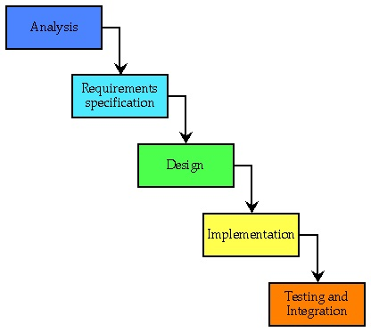
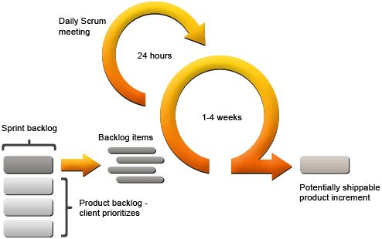

Project Phases

Analysis
In this phase the team analyzed the project, thinking at high level at the possible users, at the possible scenarios in which the system will work. Also works to build a shared vision of the project, on which each members of the team is agree.

Requirements Specification
In this phase the team set up with the customers the requirements of the project, focusing on the behavior of the final product and also on the type and structure of data in input at the system.
During the Design phase and Implementation phase the team can make some changes at the requirements, adding or removing some features depending on the issues that will rise.

Design
In this phase the team works on the design of the architecture of the system and on the behavior of the user interface to make it as user friendly, expressive and comprehensible as possible for the user.

Implementation
In this phase the team focus on the development of the various parts of the system.

Testing & Integration
In this phase the team will test the system's features in all the possible scenarios, to verify the correctness of the behavior of the system.

Roles
In the overall development process all the members of the team are developers. Adding this, threre are also other roles:
- Project leader
- Team leader
- Document manager
- Design manager
- Test manager
- Integration manager
- Database manager

Quality Assurance
During all the iterations of the Design phase and Implementation phase the Test manager will check that the system's features meet the customers desires.
Sometimes, the customers involvement guarantees that the product fits their needs.

Deliverables

To | Output | Planned week | Promised week | Late +/- | Delivered week | Rem
Supervisors/ DSD staff | Project Plan Document | 43 | 44 | +1 | 44
Supervisors/ DSD staff | Requirements Definition Document | 44 | 45 | - | -
Supervisors/ DSD staff | Design Description Document | 45 | 45 | - | -
Supervisors/ DSD staff | Alpha Prototype | 48 | 48 | - | - | 1
Supervisors/ DSD staff | Status Report | 49 | 49 | - | -
Supervisors/ DSD staff | Beta Prototype | 51 | 51 | - | - | 2
Supervisors/ DSD staff | Acceptance Test Plan | 1 | 1 | - | -
Supervisors/ DSD staff | Test Report | 2 | 2 | - | -
Supervisors/ DSD staff/ Customers | Final Project Presentation | 2 | 2 | - | -
Supervisors/ DSD staff/ Customers | Final Project Report | 3 | 3 | - | -
Supervisors/ DSD staff/ Customers | Final Product | 3 | 3 | - | - | 3

Remarks

Remark Id | Description
1 | The alpha prototype will have the basic features required, so the data parser and the DB integration
2 | The beta prototype will have the main features of the product, like a math engine, graphs, statistics.
3 | The final product will have all the features settled with the customers, like historical statistics, graphs, access control, system authentication.

Inputs

From | Required item | Planned week | Promised week | Late +/- | Delivered week | Rem
Anemometer | Yes | 44 | 44 |  |  | 1
Hydrometer | Yes | 44 | 44 |  |  | 2
Echo sounder | Yes | 44 | 44 |  |  | 3
Camera | Yes | 44 | 44 |  |  | 4

Comment: Required week = week when it is required by the project; Promised week indicates when the From expects to deliver; Late + indicates a discrepancy between Required week and Promised week; Received week is week when it was actually received; Rem is a remark index number.

Remarks

Remark Id | Description
1 | Data that measure the wind speed
2 | Data that measure the depth of water
3 | Data that measure the presence of debris on the river's bed
4 | Cameras that take pictures of pylons base for show the presence of debris on them.

Project risks
There are several risks that can affect the productivity of the team members and the accuracy of the final result of this project. Therefore, it is essential to be analyze the possibility of each risk happening, and to come up with a preventive action for each risk early in the project. This will increase the possibility of producing a high quality product and dealing with problems easier. In the table below, risks are listed, along with their possibility and preventive actions.

Possibility | Risk | Preventive action
H | Poor communication with the customer | Try to insist on more frequent meetings with the customers.
H | Undefined date for receiving input data | Try to insist on receiving it as soon as possible.
H | Unclear requirements | Try to have as much contact with customer, and ask them for feedback. Get acceptance of requirements from the customer early in the project.
M | Communication within the team | Define precise roles of the team members (team manager, team leader) and define communication flow between all the sides of the team. Also, define fixed dates for group meetings.
L | Communication within the distributed groups | This will be solved by planning to have daily meetings and try to have sprints together.
L | Lack of technical background | We deal with this by choosing technologies that are widely used and well known to the team members
L | Cultural differences | Be patient and open-minded
L | Language misunderstandings | Be patient and ask a lot of questions, in order to not get a wrong understanding of what a person meant
M | Information flow – risk of now receiving all information or of receiving correct one | Work on frequent communication especially between customer-project manager, project manager-team leader
M | Losing data | Always have a back-up of all the files that have been created during the project
M | Integration problems | Good interface definitions
L | Missing Inputs | Create fake .txt files and images with fake plausible data, to simulate the situation of the bridge

Communication
In this type of project when team members are physically separated, setting up communication protocols turns out to be a big deal. It is important to make it clear how the information will be shared among the team members and to make sure everyone has the same picture of the project.
In our team we have three separated groups of team members. We have four team members in Vastertas(SWE), two in Milan(ITA) and one in Zagreb(CRO). According to this we have agreed to have two subgroups. The first one consist of team members from Vasteras, and second one consist of members form Milano and Zagreb.
The subteam from Milano has a project manager and team from Vasteras has a team leader. Communication between these two people will be the most frequent, they will be in touch basically all the time and try to coordinate all team members and lead the project in the right direction. Having this frequent communication between these two people, we hope we will be able to react more quickly to any unexpected problem.
The next stage of communication within the group are group meetings. We agree to have at least one weekly meeting. More meetings during the week will be organized if needed. Each group meeting will be documented in the minutes of meeting document.
Finally, meetings within subgroups will be organized on a daily bases.
As technical support for communication, Skype, Google hangout and spreadsheets will be used. For sharing documentation and code Git will be used.

Configuration management
- Github will be the repository for code and product documentation
- The Github policy and the internal group policies provide information about coordinated usage and preventive action to take
- Google Drive is will be the tool used for drafting documents and to manage and coordinate some actions
- The Github manager and the Documentation manager will handle the corrective actions regarding merging or correcting the documents

Project plan
In this section, the project plan will be presented. It will include a list of all the milestones of the project along with the responsible team members associated with the milestone, and the planned week for the milestone. Also, the activity plan will be presented with a Gantt chart.

Time schedule
In the table below, the milestones are presented.
Id | Milestone  Description | Responsible Dept./Initials | Finished week |  |  |  | Metr | Rem
Id | Milestone  Description | Responsible Dept./Initials | Plan | Forecast |  | Actual | Metr | Rem
 |  |  |  | Week | +/- | Actual | Metr | Rem
M-001 | Project Plan & Vision | All | 42 | 42 | 0 | 43
M-002 | Requirements gathering | All | 43 | 43 | 0 | 43
M-003 | Requirements document | All | 43 | 44 | 1 | 43
M-004 | System Design | All | 43 | 44 | 0 | 43
M-005 | Requirement Document | All | 44 | 44 | 0 | 44
M-006 | Design Document | All | 44 | 44 | 0 | 44
M-007 | Status Report | All | 44 | 44 | 0 | 44
M-008 | Organize Repository | Marko Brcic | 45 | 45 | 0 | 45
M-009 | Team Policies | Marko Brcic | 45 | 45 | 0 | 45
M-010 | Share telephone number | All | 45 | 45 | 0 | 45
M-011 | Modify Requirement Doc | Dzana Kujan | 45 | 46 | 1 | 45
M-012 | Modify Design Doc | Lorenzo Pagliari | 45 | 46 | 1 | 45
M-013 | Setup tools on PC | All | 45 | 45 | 0 | 45
M-014 | Change DB | Jorn Tillmanns | 45 | 45 | 0 | 45
M-015 | Implementation Parser | Jorn Tillmanns | 45 | 45 | 0 | 45
M-016 | Implementation DAO | Jorn Tillmanns | 45 | 45 | 0 | 45
M-017 | Start Implementation Math | Andrea Bottoli | 45 | 46 | 1 | 45
M-018 | Test Parser | Miraldi Fifo | 46 | 47 | 0 | 46
M-019 | Test Classes alpha prot. | Miraldi Fifo | 46 | 47 | 0 | 46
M-020 | Alpha prototype | All | 46 | 48 | 2 | 46
M-021 | Requirements Gathering | Andrea Bottoli | 47 | 47 | 0 | 47
M-022 | Update Design Doc. | Andrea Bottoli | 47 | 48 | 0 | 48
M-023 | Update Requirem. Doc. | Dzana Kujan | 47 | 48 | 0 | 48
M-024 | Finalize Math Engine | Lorenzo Pagliari | 48 | 49 | 1 | 48
M-025 | Web Design | Miraldi Fifo | 48 | 49 | 1 | 48
M-026 | Status Report | All | 49 | 49 | 0 | 48
M-027 | UserLoginSystem | Jorn Tillmanns | 49 | 50 | 1 | 48
M-028 | Finalize Math Engine | Lorenzo Pagliari | 49 | 50 | 0 | 49
M-029 | Junit tests v1 | Miraldi Fifo | 49 | 50 | 0 | 49
M-030 | Web Site Mockups | Nikola Radisavljevic | 49 | 49 | 0 | 49
M-031 | Web Site Graphs | Dzana Kujan | 49 | 50 | 0 | 49
M-032 | Beta Prototype | All | 50 | 51 | 0 | 50
M-033 | Beta Prototype pres. | Lorenzo Pagliari | 51 | 51 | 0 | 51
M-034 | Technical documentation | Andrea Bottoli | 51 | 51 | 0 | 51
M-035 | Acceptance Test Plan | Miraldi Fifo | 51 | 52 | 0 | 52
M-036 | Test Report | Miraldi Fifo | 01 | 02 | 1 | 52
M-037 | Final Presentation | All | 02 | 02 | 0 | 01
M-038 | Final Documentation | All | 02 | 03 | 1 | 01
M-039 | Final Product | All | 02 | 03 | 1 | 01
M-040 | Final Questionnaire | All | 02 | 03 | 1 | 01

Activity plan
The activity plan is presented in the Gantt chart below. The activities and milestones are shown.
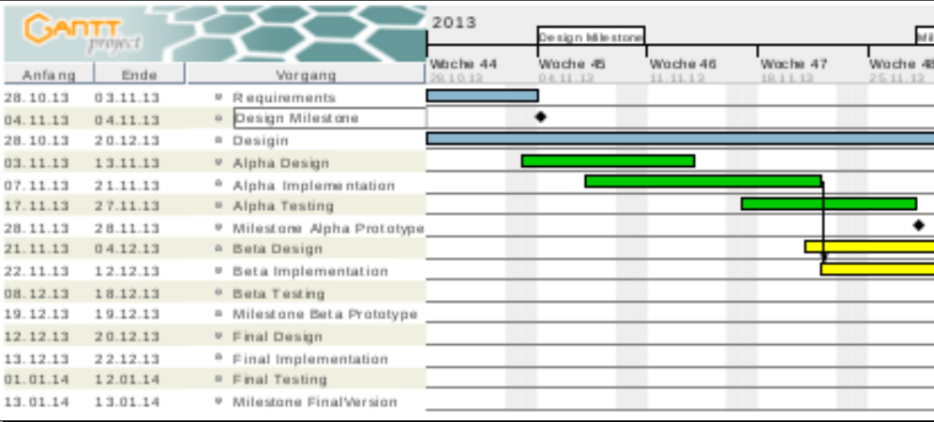
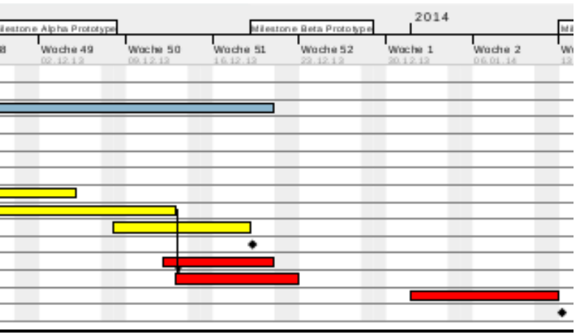

The requirements analysis is planned to be finished earlier in the project, and it is not planned to be updated much in the following prototypes. This decision was made because the customers know what they want and are not available for frequent communication with the development team.
The design activity is planned throughout the project. This is due to the fact that the design decisions will be updated in each prototype development cycle. The design document will be also constantly updated, in order to be consistent with the working prototypes at all times. The design activity includes design of database, UI design and interface design, which should all be finished before starting work on the Alpha prototype.
The product will be developed incrementally, and as a result of that, there will be three increments: Alpha, Beta and Final prototype. Each prototype contains the activity of design, implementation and testing. This will ensure high quality of each prototype.
In the alpha prototype, the basic functionalities of the system will be implemented. At the end of this increment, we will have a working product which will contain at least reading of one sensor data from the database, and presenting that data on the user interface. This will be the foundation of the following increments, and the product that we will build upon.
The beta prototype will take longer time to develop, compared to the Alpha and Final prototypes. It is because the plan is to introduce most of the functionalities in this prototype. This means that the database will be upgraded to support all sensors, and all sensor data will be available on the UI, as well as all calculation results.
The final prototype will include the finalization of requirements and will concentrate on adding minor fixes, enhancing the UI or adding low priority functionality.
In order to achieve high quality of the product, each prototype will be tested.

ID | Predecessor | Activity | Days | Mdays | Rem.
M-001 | / | Project Plan & Vision | 6 | 35
M-002 | M-001, M-002 | Requirements gathering | 2 | 8
M-003 | M-001, M-002 | Requirements document | 3 | 12
Design phase
M-004 | M-003 | System Design | 3 | 10
M-006 | M-003, M-004 | Design Document | 3 | 6
Setup phase
M-008 | / | Organize Repository | 2 | 4
M-008 | / | Team Policies | 2 | 6
M-008 | M-003 | Modify Requirement Doc | 2 | 6
M-008 | M-006 | Modify Design Doc | 2 | 6
Alpha phase
M-014 | M-008 | Implement DB | 2 | 20
M-015 | M-008,M-014 | Implementation Parser | 4 | 28
M-016 | M-008,M-014 | Implementation DAO | 4 | 20
M-018 | M-015,M-016 | Test Parser | 2 | 8
M-019 | M-018 | Test Classes alpha prototype | 2 | 8
M-020 | M-015,M-016 | Alpha prototype | 2 | 25
Beta phase
M-021 |  | Requirements Gathering | 1 | 4
M-022 | M-021 | Update Design Doc. | 1 | 4
M-023 | M-021 | Update Requirement Document | 1 | 4
M-028 | M-022,M-023,  M-024 | Finalize Math Engine | 30 | 26
M-029 | M-028 | Junit tests v1 | 2 | 10
M-025 | M-028 | Web Design | 2 | 9
M-027 | M-025 | UserLoginSystem | 5 | 5
M-030 | M-025,M-028 | Web Site Mockups | 1 | 3
M-031 | M-025, M-028 | Web Site Graphs | 3 | 20
M-032 | M-025,M-028  M-031 | Beta Prototype | 3 | 10
Last phase
M-039 | M-032 | Final Product | 8 | 10
M-034 | M-022, M-023, M-039 | Technical documentation | 5 | 8
M-035 | M-023, M-039 | Acceptance Test Plan | 3 | 5
M-036 | M-039 | Test Report | 3 | 8
M-038 | M-039 | Final Documentation | 3 | 8

Planned effort (days) | Planned effort (man-days)
110 | 336

Remarks

Remark Id | Description

